CS4187 Computer Vision and Interactivity

Homework Assignment #1

Total Marks: 10 Points **Deadline: 2020.10.16, 23:59PM**

**Question 1 (2 Points).**

Please write a program using OpenFrameworks, to merge the following two images to overlay the running man (running.jpg) on the road background (bg.jpg).

Images to Load:

[(Link)](https://canvas.cityu.edu.hk/files/4675300/download?download_frd=1)

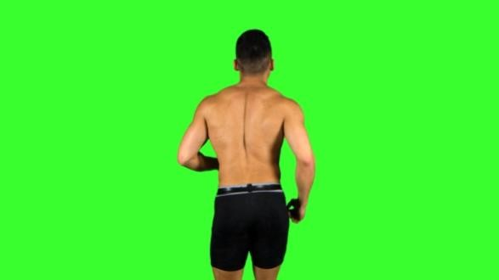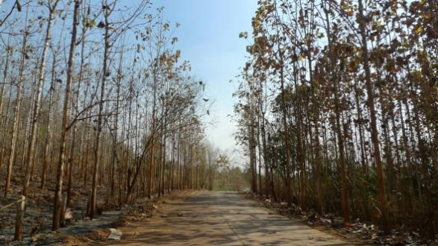

[(Link)](https://canvas.cityu.edu.hk/files/4675297/download?download_frd=1)

Output:

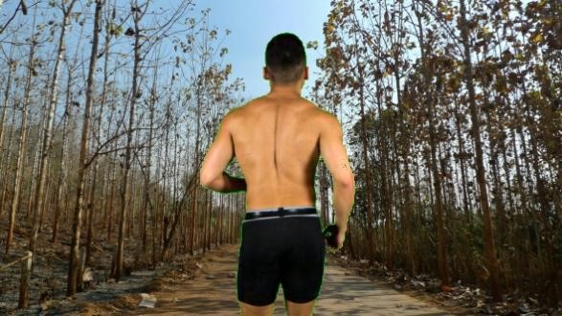

Grading Breakdown:

1. The result (1 point) 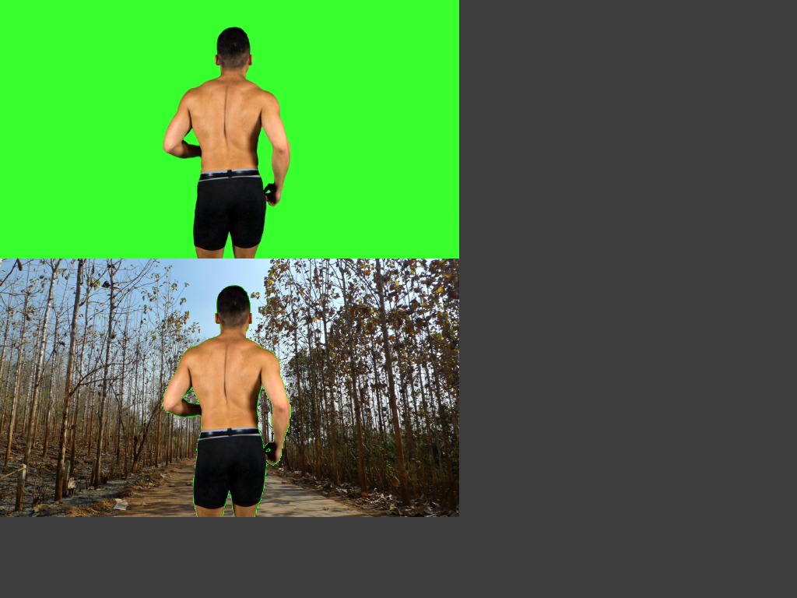
2. Explain your solution (1 point)

Ans: Since the background of the man's picture is green, I just need to determine whether the pixels in the image are green, and if so, I just replace it with the pixels of the background image.

**Question 2 (5 Points)**

Here we have two noisy images:

1. lena.jpg ([Link)](https://canvas.cityu.edu.hk/files/4675299/download?download_frd=1)

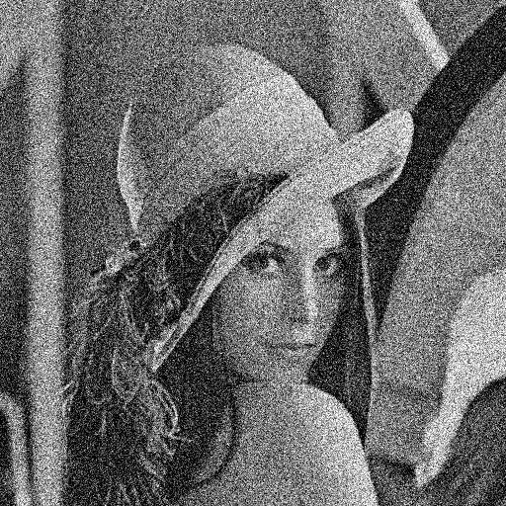

1. circuit.tif ([Link)](https://canvas.cityu.edu.hk/files/4675298/download?download_frd=1)

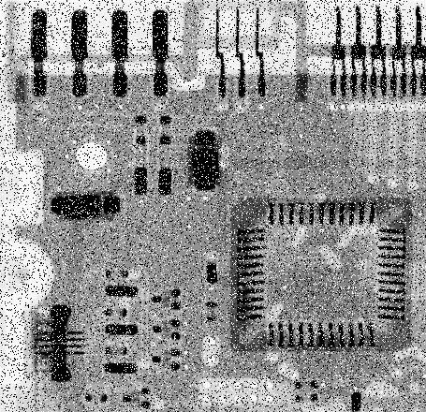

Please write a program using OpenFrameworks, to apply the Box filter, the Gaussian filter, and the Media filter, with different parameters (i.e., sizes of kernel: 3, 5, 7, 9, 11, variant in the Gaussian function: 4, 5, 6, 7, 8, 9, 10), to reduce the noise in these two images, and report the results. In addition, please find out the best filters for each image accordingly, and explain why.

Grading Breakdown:

1. Box filter with different parameters for the two images (1 point) 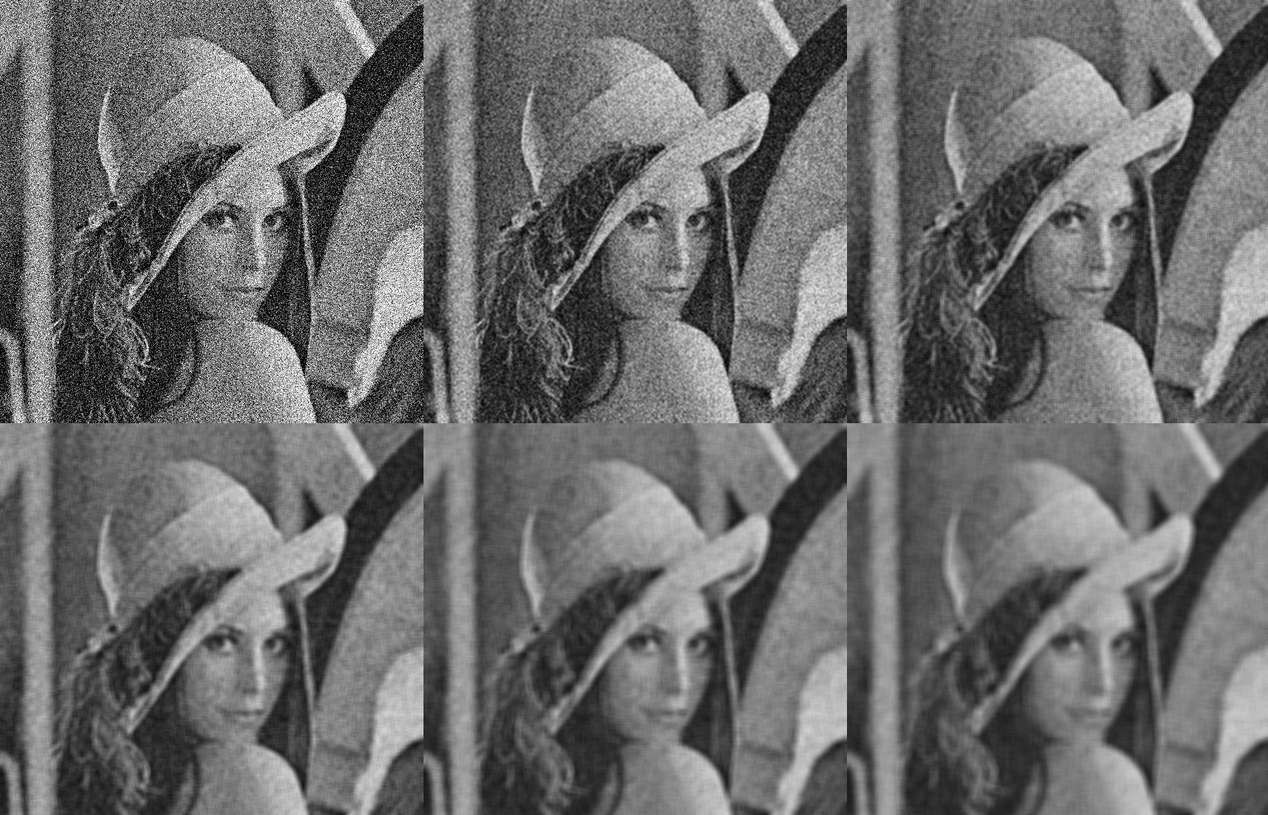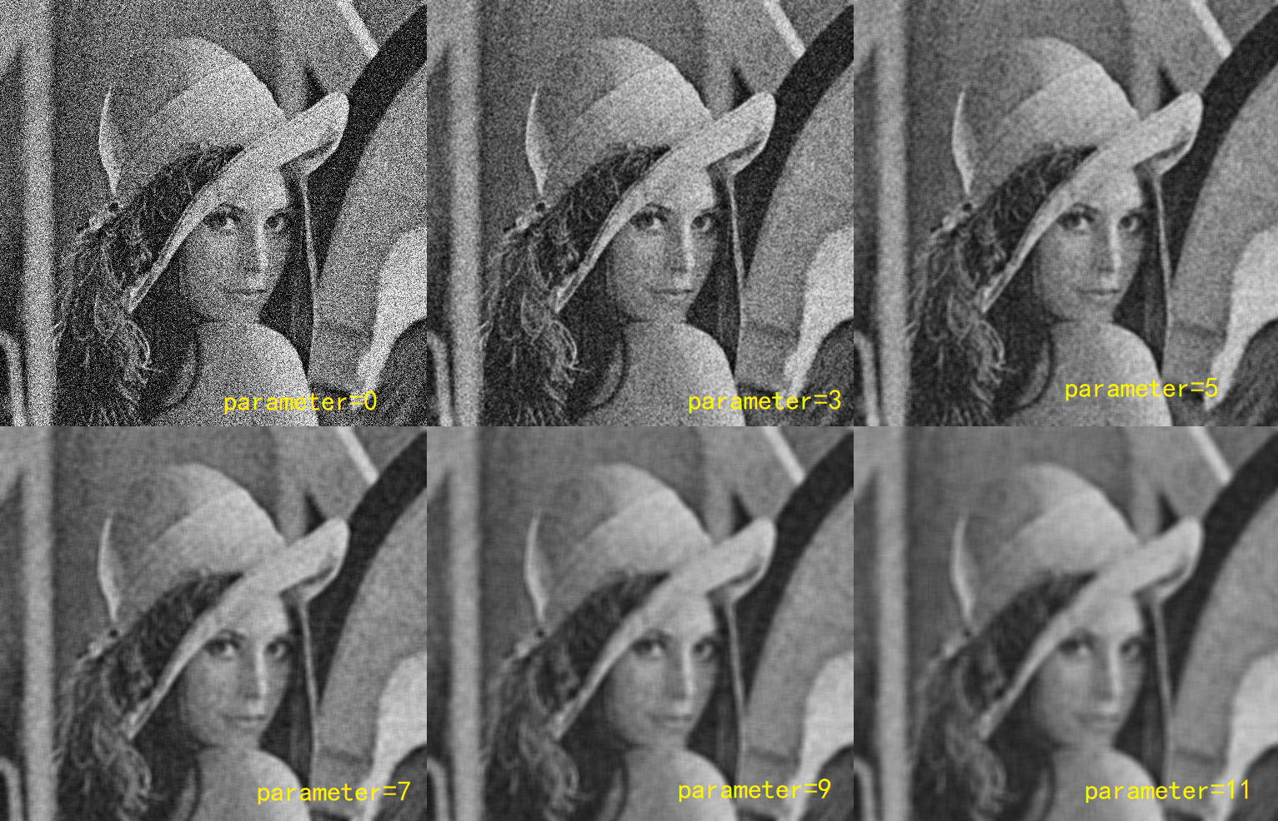 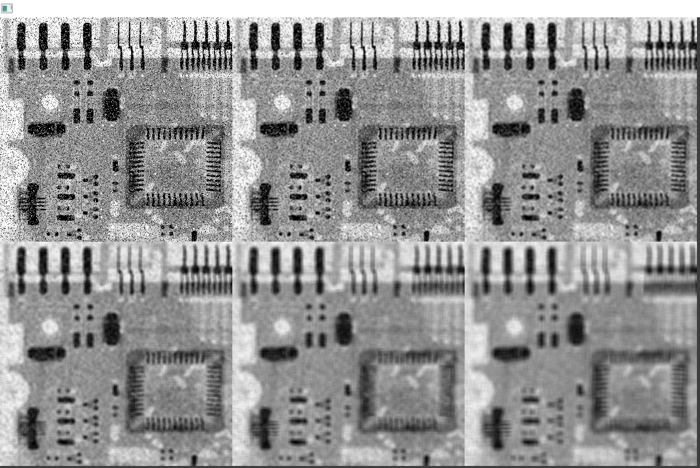 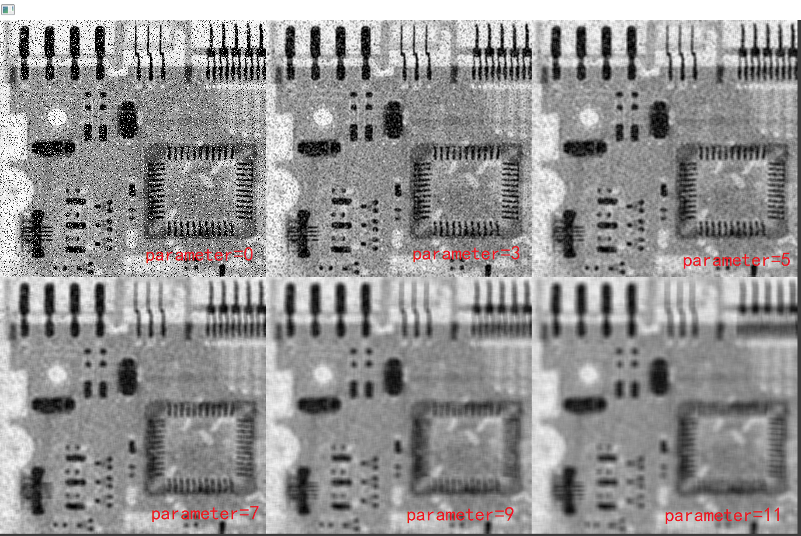
2. Gaussian filter with different parameters for the two images (1 point) 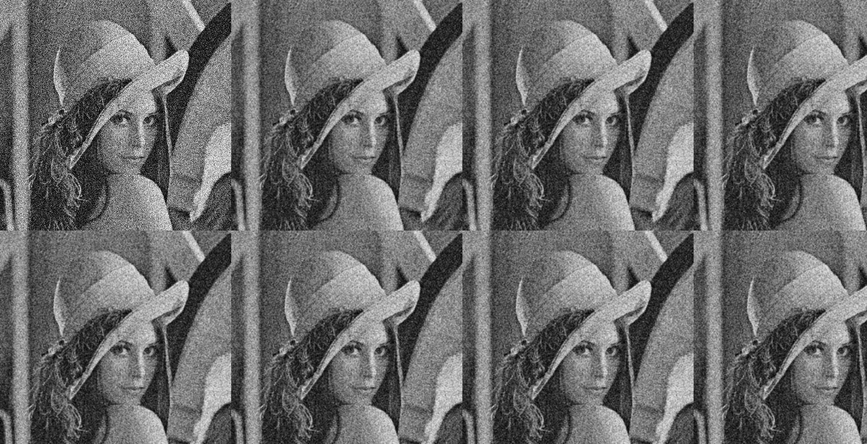 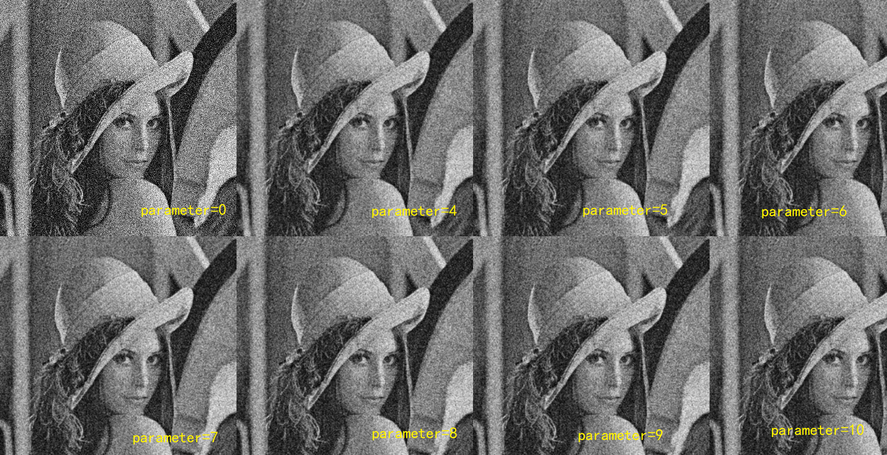 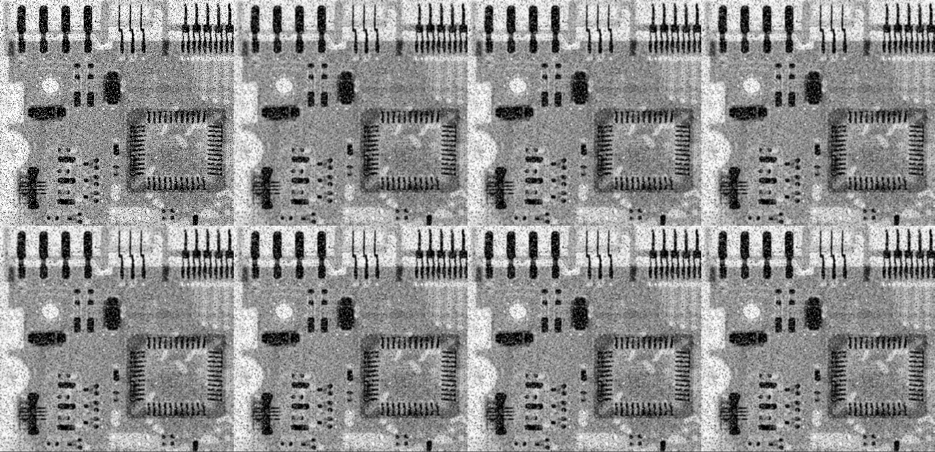 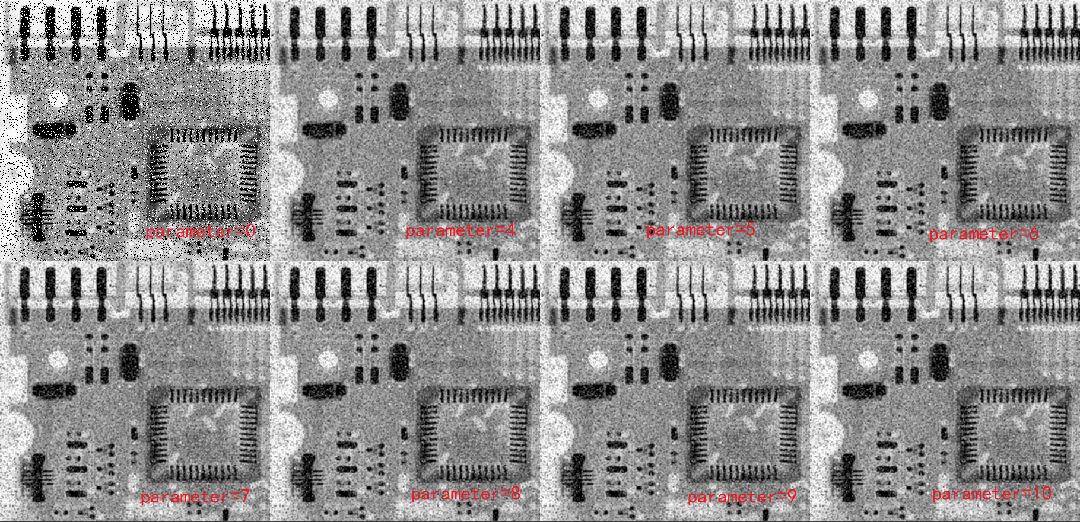
3. Median filter with different parameters for the two images (1 point) 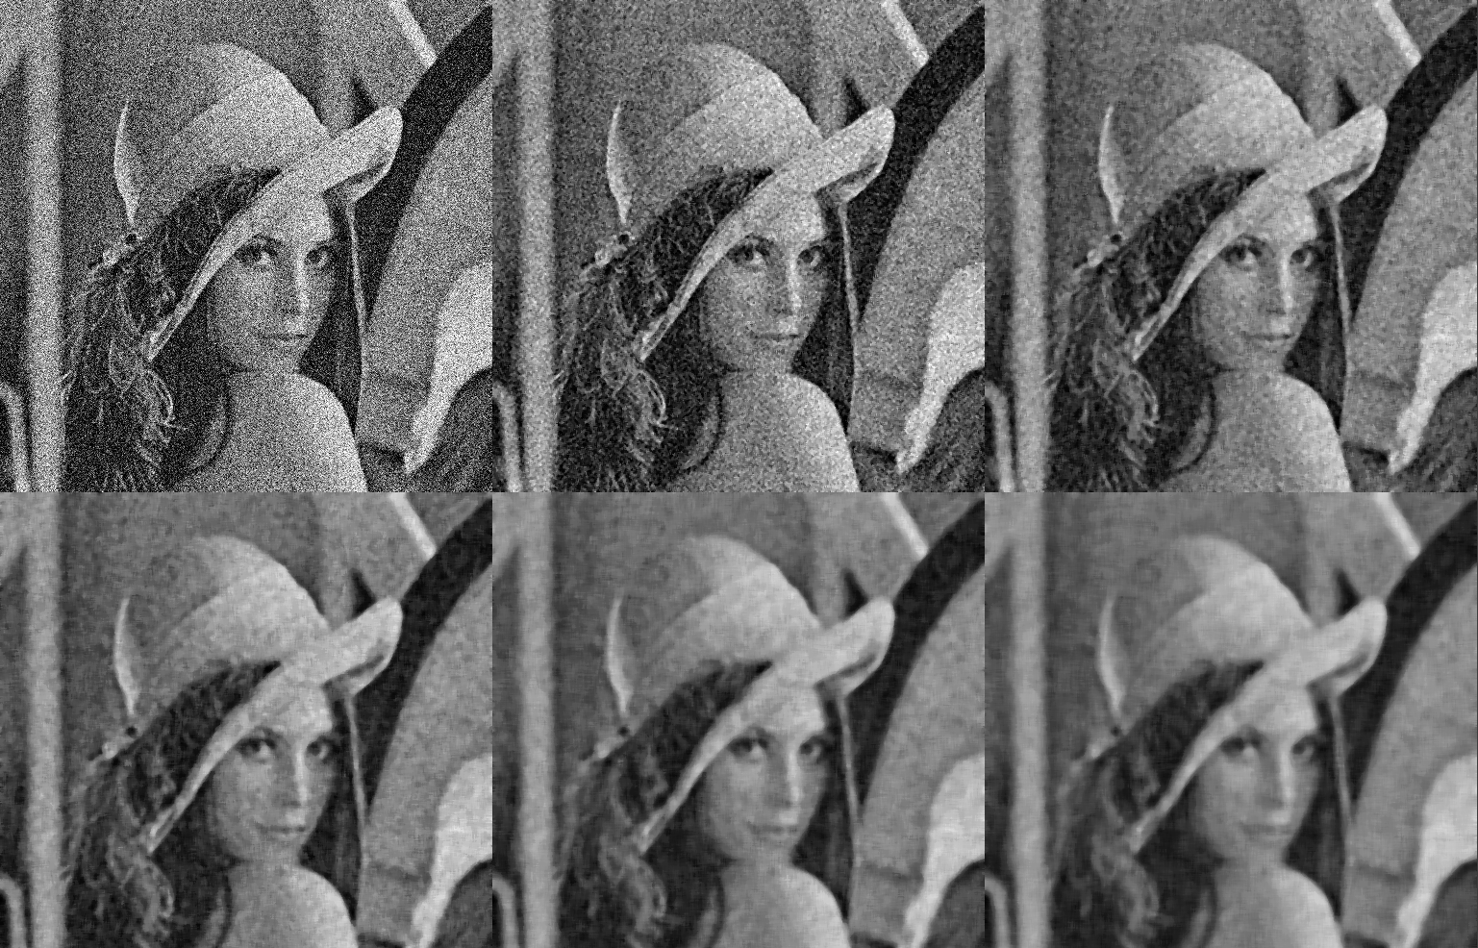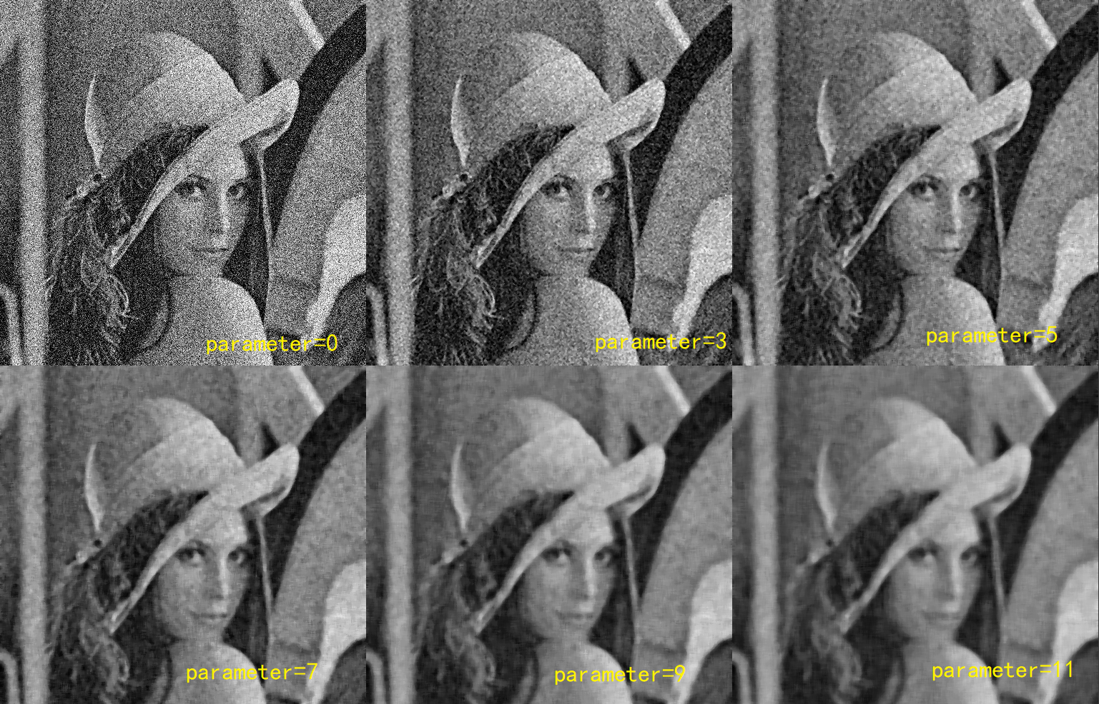 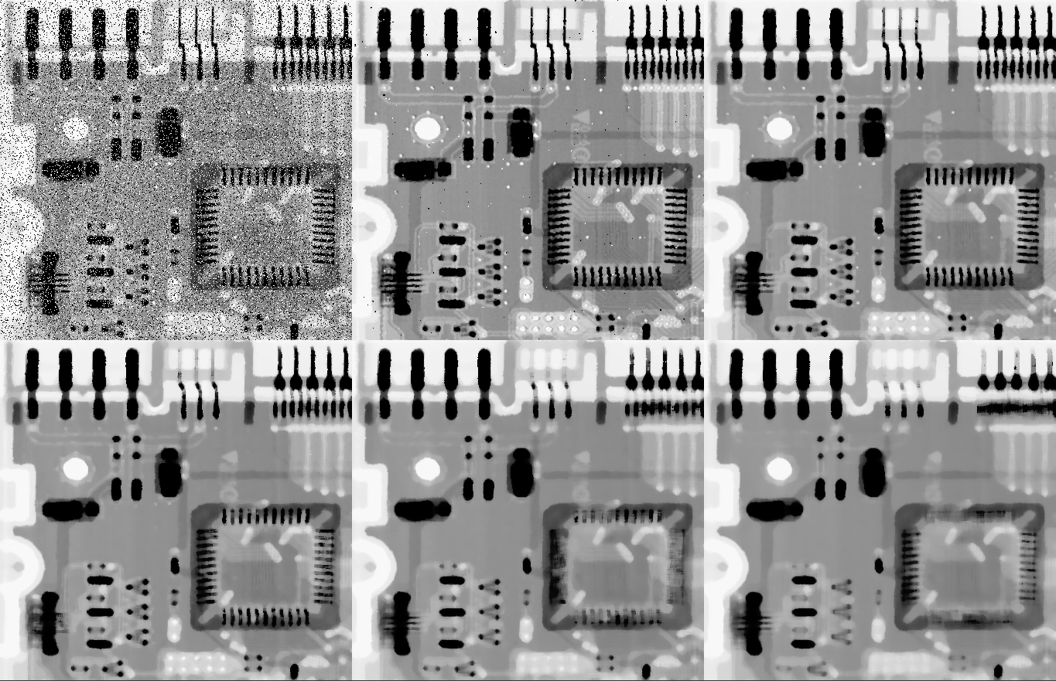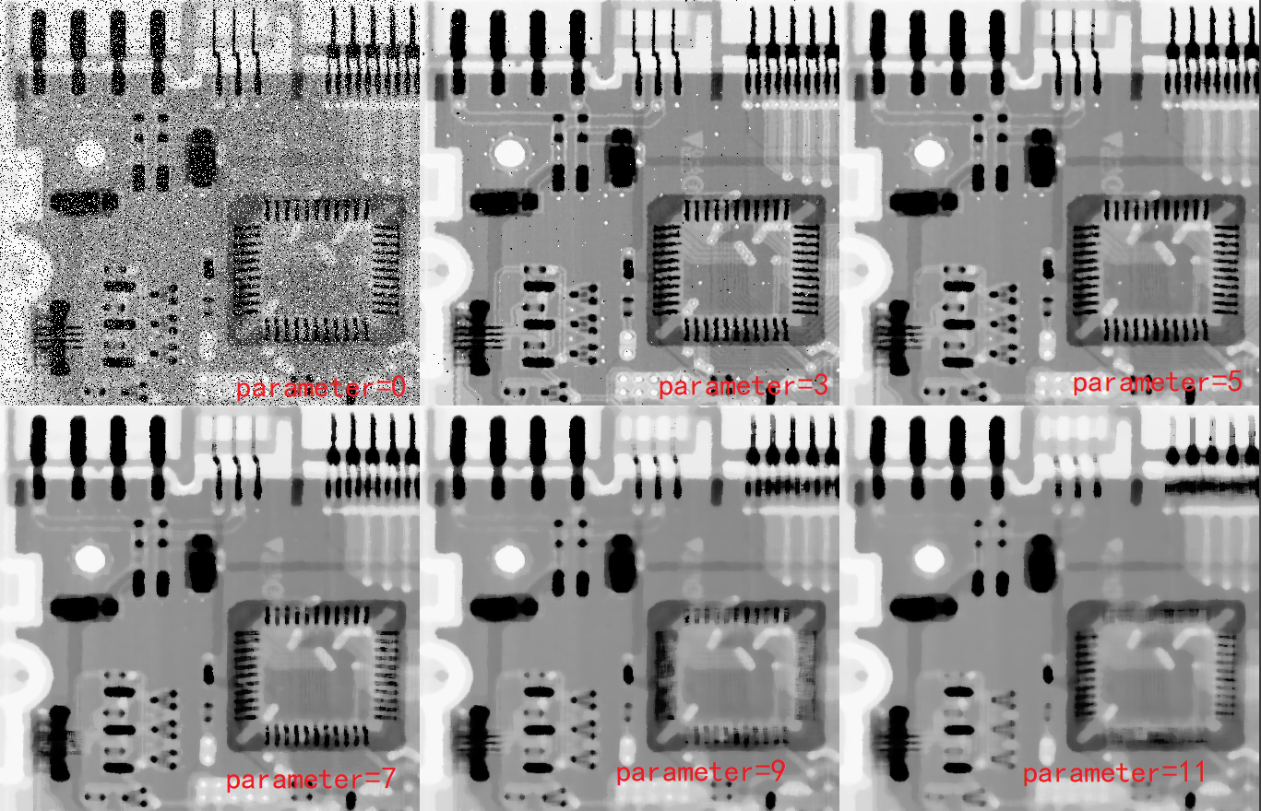
4. Find the best filters for each image accordingly, and explain why. (2 point)

Ans:

For Lena, the Gaussian filtering is the best because the other two filtering methods will blur the image.

However, for Circuit, media filter is better. Because box filtering will make the image blurred, while Gaussian filtering has poor denoising ability.

**Question 3 (3 points).**

Please write a program using OpenFrameworks, to capture the real-time grayscale image stream in grayscale from a webcam, and plot the histogram of each frame in real time. In addition, please add a mouse-click interaction, so that when the user click on the webcam image, **invert** the color of the pixel at the clicked position. Meanwhile, **invert** all the other pixels with the same color/intensity value as the clicked pixel.

Please see a video demo for reference (link: mouse is hidden due to the screen recording..).

Grading Breakdown:

1. Capture the real-time grayscale image stream in grayscale from a webcam (1 point)
2. Plot the histogram of each frame in real time (1 point)
3. Mouse-click interaction (1 point)

**Submission Method:**

Please write a report, stating your name and student No., to explain briefly your solution for each question, and zip it with your code, and submit the zip file to the canvas.